**Excel Assignment - 15**

Dataset:

https://docs.google.com/spreadsheets/d/1IRSEnmgz8Ro276-GslknRNk0zlrB5CZH1YrnT71kqFM/edit?usp=sharing

Use the above dataset and answer the following questions.

1. Create a Pivot table and show what the main export product is?

Ans. 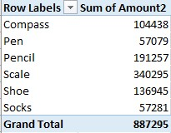

So the main export of product is scale.

2. Create a bar graph showing the amount spent on each product?

Ans. 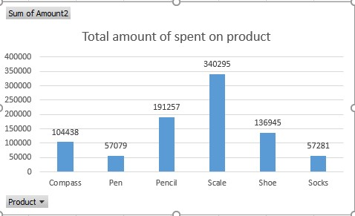

3. Create a Pivot table to show the sales in each city

Ans. 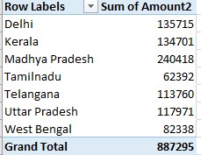

4. Create a chart showing the amount spent on each product in each city.

Ans. 